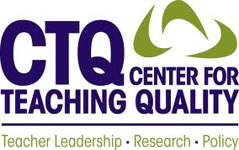

2014 Teacher Leadership Initiative
Capstone Project
Revisiting and Revising School Based MTSS/RTI Practices

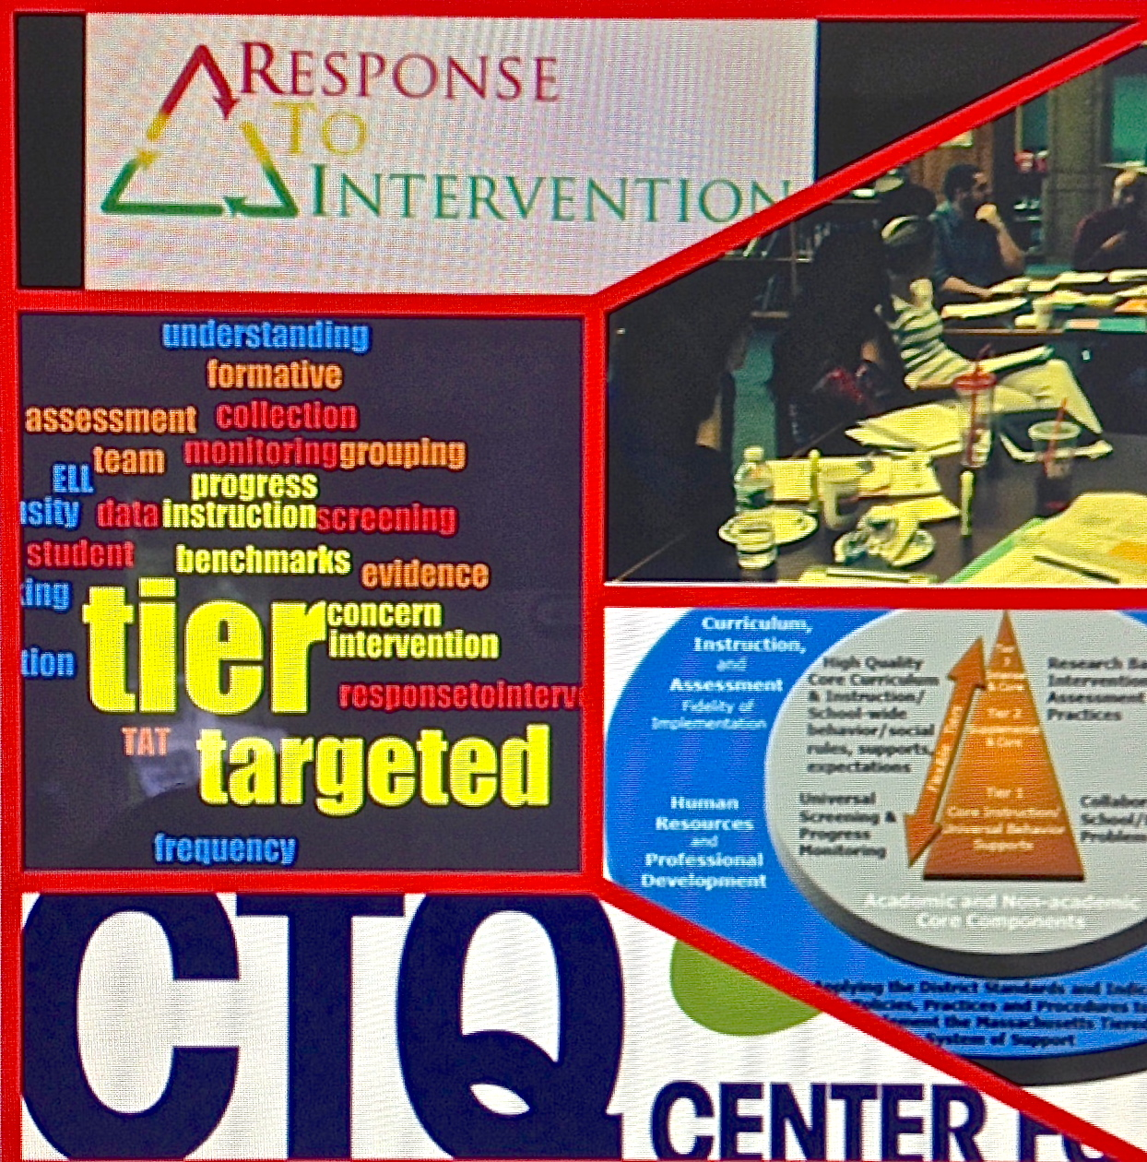

Submitted By
Patrice Bucci
TLI Cohort 4
Massachusetts

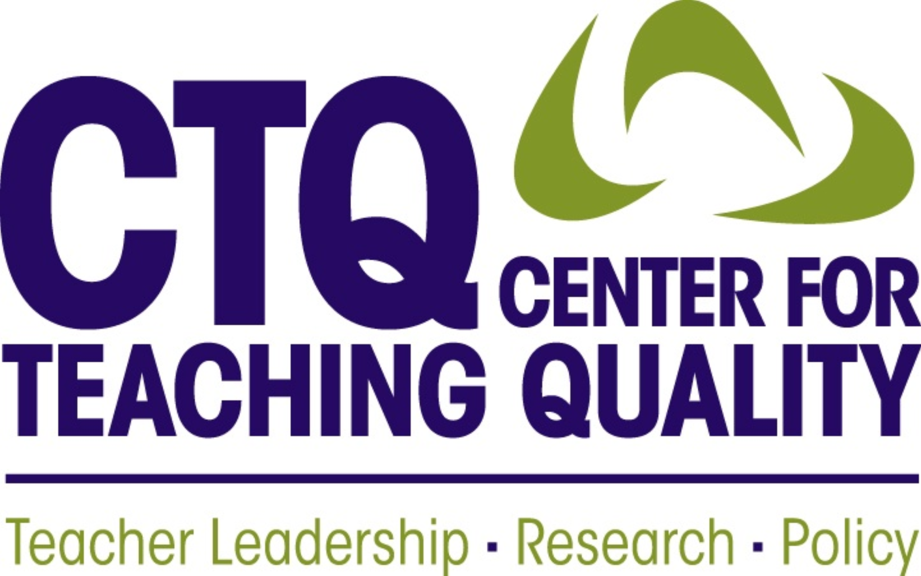



Table of Contents

Leadership Profile and Context …………………………………………………………..… 4
Competency Selected …………………………………………………………………….…6
Evidence of Meeting Standards ……………………………………………………..7
Evidence of Success …………………………………………………………….…..8
Project Summary and Goals ……………………………………………………………..…9
Description………………………………………………………………………….9
Intended Goals ……………………………………………………………………10
Rationale …………………………………………………………………………10
Intended Outcomes……………………………………………………………..…10
Leadership Action Plan …………………………………………………………..11
Reflections on Leadership Growth………………………………………………………..14
Artifacts …………………………………………………………………………………..17
Comments from Stakeholders, Participants ………………………………………………27
Going Forward ……………………………………………………………………………29

Leadership Profile and Context
As a veteran teacher of over 25 years, I have had many opportunities to engage in teacher leadership roles. My experience in the field has included direct teaching services within a Title I literacy program, literacy coaching as part of state and federal education grants, presenting at state conferences, and providing school and district based professional development.
The offer to apply for the NEA/CTQ 2014 Teacher Leadership Initiative caught my interest. The guiding questions in the application provoked much thought and ultimately, I decided to apply. My passion for working with teachers, enhancing collaborative learning, and seeing a void of instructional leadership that supports teachers, inspired me to examine the goals and mission of this nationwide effort offered by the NEA, the Center for Teaching Quality and the National Board of Professional Teaching Standards. The Teacher Leadership Initiative offered an opportunity to advance teacher leadership skills as an alternative to pursuing traditional administrative roles.
Upon reviewing my initial application for the program, I realized that the entire NEA/CTQ Teacher Leadership Initiative experience aligned perfectly with my expectations, and with the intended outcomes of this national effort. Growing a cadre of teacher leaders begins with challenging the traditional view of developing school leaders as solely administrators or principals. Fostering teacher leadership in schools means identifying and developing those teachers who are actively involved in team building, fostering and developing school based professional learning communities, and engaging in action research. Actively seeking those teachers who build trust among colleagues and build confidence in others is key to identifying potential teacher leaders. It is refreshing to see that the NEA/CTQ have made such expansive efforts to actively seek to grow teacher leaders.
To promote and enhance the role of teacher leaders in schools, all the major stakeholders need to understand the value of such a role. Administration, union leadership, and policy level leaders can enhance the development of teacher leaders through the expansion of programs that focus on team development, collaborative culture, ongoing professional development, action research, and inclusive professional learning communities. Developing cadres of teacher leaders that build trust among colleagues, diagnose organizational conditions, examine best practices in instruction, engage in action research, and develop and implement strategic plans will serve to enhance professional practice and more importantly, student achievement. Teacher leader capacity can be enhanced further by fostering inquiry skills that examine school culture, analyze strengths and areas for growth, and anticipate potential challenges. Efforts that promote teacher leaders is less about developing “experts”, and more about developing team members that facilitate colleague growth. The efforts of the Teacher Leadership Initiative have demonstrated they understand what “teacher leadership” means, how to identify it, and most importantly how to support it.
The year long effort by these three organizations (NEA, CTQ, NBPTS), fostered and promoted teacher leadership efforts, provided access to thought leaders and researchers from across the field, and supported efforts with an expansive range of resources.
Working with the inaugural cohort of TLI Teacher Leaders has been enriching, enlightening, and invigorating. I have honed my teacher leadership skills, expanded my professional learning network, and increased efforts to advocate for teachers and students through social networking, leading school based PLC’s, writing for various educational blogs, and curating resources for colleagues.
Competencies Selected: Instructional Leadership
Early in the Teacher Leadership Initiative efforts, members were encouraged to review the teacher leadership competencies outlined by Teacher Leadership Consortium as well as the National Education Leadership Competencies. Review of these competencies expanded my awareness of the multifaceted aspect of teacher leadership.
My experience in the Teacher Leadership initiative enabled me to review the overarching competencies of instructional leadership, policy leadership and association leadership. I selected to focus my leadership challenge in the competency area of instructional leadership.
I chose the area of instructional leadership because it most aligned with my skill set, my passion, and my goal to develop and foster teacher leadership skills that can effect change. I sought to grow in the over arching competencies of reflective practice, personal effectiveness, group processes, adult learning and technological facility. Additionally, this choice enabled me to improve coaching skills, foster collaborative relationships with teachers and major stakeholders, as well as further develop professional learning communities.
More specifically, my leadership challenge project enabled me to move along the continuum of growth in each of the instructional leadership competencies. Personal reflection using the Teacher Leadership Competency rubric led to awareness of growth in the areas of coaching and mentoring, facilitating collaborative relationships, as well as advocacy skills.

NEA, CTQ, NPBTS Teacher Leadership Competencies, 2014
NEA Teacher Leadership Competency | Pre TLI | Post TLI
Coaching and Mentoring | Developing  - Promotes Collegiality, trust, and respect.  - Fosters Development of fellow teachers, valuing and respecting when they are in their personal practice  - Helps colleagues to make their own professional decisions by asking appropriate questions and encouraging reflection | Performing  - Engages in formal roles of coaching and mentoring  - Utilizes multiple measures to identify effective teaching and successful student learning  - Connects colleagues based on strengths, needs and personal academic qualities, and decides how to meet those needs once connections have been made.  - Identifies others who would be good mentors and or leaders
Facilitating Collaborative Relationships | Developing  - Understands policies and initiatives that impact teaching and learning  - Knows how to build consensus and peer capacity on issues related to student learning | Transforming  - Reflects on his/her leadership and its impact on colleagues  - Objectively evaluates and learns from decision making processes and their outcomes  - Reaches out and works effectively regardless of time or geography, bringing together diverse perspectives and contexts, uniting them in shared work and vision
Community Awareness, Engagement and Advocacy | Developing  - Uses a deep understanding of the school, cultural, community, political and educational landscapes to meaningfully connect and create buy in with families, schools, and community partners in order to address student needs. | Performing  - Facilitates the creation of genuine partnerships, including those among colleagues, students, parents, communities, policy makers and beyond to:  - Address the current and future needs of students  - Inspire and improve the community  - Elevate the profession
Additionally, my TLI experience improved my reflective practice, helped me to document personal effectiveness, further understand adult learning, and further expand my ability to engage with and utilize technology.
When reviewing the Teacher Leader Model Standards, and reflecting on the six domains (Fostering Collaborative Culture, Accessing and Using Research, Promoting Professional Learning, Facilitating Improvements in Instruction and Student Learning, Promoting the Use of Assessments in Data for School and District Improvement, Improving Outreach and Collaboration with Families and Community, and Advocating for Student Learning and the Profession) I realized that I touched upon many of those standards through my TLI experience.
Teacher Leaders Model Standard | Evidence of Meeting Standard
Fostering Collaborative Culture to Support Educator Development and Student Learning | Lead School Based Professional  Community, Models skills of listening, presenting ideas, leading discussions, etc.
Accessing and Using Research to Improve Practice and Student Learning | Created Livebinder of Resources for PLC and staff members,  Created Matrix of Resources (Research, Think tanks, Professional Journals, etc)  Analyzed student learning data (Literacy Profile sheets, MCAS, DRA results etc)  Interpreted data results, Identified students of concern
Promoting Professional Learning for Continuous Improvement | Created PLC, plan team based meetings, offer constructive feedback, provide guiding questions
Facilitating Improvements in Instruction and Student Learning | Facilitated collection, analysis and use of assessment data to improve identification of students of concern  Engaged in reflective dialogue with colleagues  Served as PLC team leader  Made use of emerging technologies  Promoted research based instructional strategies
Promoting the Use of Assessments and Data for School and District Improvement | Collaborated with colleagues, created climate of inquiry, critical reflection  Analyzed data in teams
Improving Outreach and Collaboration with Families and Community | Attended to need for two way communication with parents regarding students of concern
Advocating for Student Learning and the Profession | Advocates for access to professional development and professional learning resources for teachers
Project Summary and Goals
Choosing a leadership challenge involved a range of steps that helped me to identify an area of focus, develop a rationale, articulate goals, and outline intended outcomes. TLI participants engaged in a range of activities that helped us to narrow our focus, develop an action plan, and implement steps to take action.
Using a variety of graphic organizers to help us to identify our leadership challenge and reflect on potential goals and outcomes, the members of the Teacher Leadership cohort collaborated and supported each other in their efforts. With a group of “critical friends” to offer input, advice, recommendations, and feedback we were able to craft our leadership challenges in ways that further developed our projects.
The steps to identifying and deciding on a project involved the following:
- Identifying strengths, skills and passions
- Identifying Vision for Teacher Leadership
- Crafting Leadership Challenge Action Plan
- Participating in “Face to Face” State TLI Meeting to share/review leadership project action plan
- Sharing with “Critical Friends” via Google Hangouts
(See Appendix for above artifacts)
Description of Leadership Challenge Project:
Revisiting and Revising the Roberts School MTSS/RTI/TAT Team Processes and Protocols
The 2014 NEA/CTQ Teacher Leadership initiative supports the vision of teachers helping teachers. With expanding leadership and mentoring skills supported by the TLI experience, I lead the Roberts School MTSS/RTI/TAT PLC. The efforts aimed to revisit, review and renew current practices in school based efforts to implement an effective RTI plan (District Priority Goal # 6). Efforts focused on building knowledge, researching best practices in RTI, formalizing processes and paperwork, and streamlining data collection. The team endeavored to develop specific actions based on a needs assessment. I crafted and implemented an action plan and formed subcommittees to engage in knowledge building and sharing. It was the aim of this PLC to take part in professional collaboration toward common goals, engage teacher voices, and create an RTI/TAT Handbook that would serve as a useful resource for paperwork, protocols, roles & responsibilities, and a matrix of actionable suggestions for further targeted instruction.
Rationale/Purpose:
•Revisit and revise current Roberts school MTSS/ RTI and TAT team practice
•Align efforts with state, district, and school goals of moving toward a system of tiered instruction and tiered intervention
Intended Outcomes:
–Clarification/Revision of Roberts MTSS/RTI/TAT Practices & Protocols
–Align Roberts’s goals with district goals & Conditions of Effective Schools
–Clear Identification of roles/responsibilities of MTSS/RTI/ TAT team, teachers, and specialists
–Subcommittee Reviews (Protocols/Forms/Paperwork/Tiered Instruction/Matrix of Actionable Suggestions)
–Create Handbook for MTSS/RTI/TAT team
–Present to administration/staff for comments/concerns/ questions, revisions, approval

My Leadership Challenge Action Plan
If…Then…
My initial musings were such that, If I did a school based RTI/TAT PLC,
Then knowledge building, revision of practices, and improved identification of students of concern might happen. Teachers would have a common vision, mission and language with respect to identifying students of concern and providing those students with targeted, tiered instruction.
My action plan evolved as follows:
Action Step #1: Meet with Principal, Asst. Superintendent to pitch idea
Strategy: Identify why school based RTI/TAT practices need to be revisited and revised (cite WWC Research Reports)
Action Step #2: Meet with staff to pitch PLC
Strategy: Recognize teacher/staff concerns/confusions with respect to current RTI/TAT practices, Recognize need to align RTI/TAT practices with 2014 District Goals, Recognize district concerns about high number of referrals to SPED/TAT
Action Step #3:Conduct Needs Assessment
Strategy: Identify specific areas of school based RTI/TAT that need revision (TAT form, Data Collection, Meeting protocols and paperwork, etc)
Action Step #4: Solicit steering committee (PLC) members
Strategy: Create steering committee members that include grade level representation, specialist (compensatory program) members, and administration. Stress importance of including those with specific certifications (reading specialists, speech therapists, LD specialists). Cite RTI Action Network recommendations
Action Step #5: Set Meeting times, PLC protocols
Strategy: Assure meeting times, protocols, and roles and responsibilities are clearly understood
Action Step #6: Share Action plan
Strategy: Assure understanding of specific goals, timeline for goals, expected outcomes
Action Step #7: Have participants select identified areas they want to work in ( (RTI TAT paperwork, Data Collection, Matrix of Suggested Tiered/Targeted Instruction, etc)
Strategy: Share knowledge building responsibilities, share work load
Action Step #8: Have group make recommendations based on work done
Strategy: Work toward final product development
Action Step #9: Create final product ( RTI/TAT Practice Handbook for RTI/TAT team and staff)
Strategy: To have clear protocols, expectations that everyone understands. To have a product that all teachers/staff/new teachers can utilize
Action Step #10: Share final product with principal/staff for questions, comments, concerns, and potential revisions.
Evidence of Success/Effectiveness
Leading the professional learning community described in my action plan took place over many months. While the efforts are ongoing, the end is in sight. With the final two PLC meetings to take place in October 2014, the final product associated with this effort looks to be completed by December 2014. Success is identified as follows:
- Completed Action Plan
- Completed pitch/letter of intent to Asst. Superintendent, Principal
teachers
- Completed Survey for Teacher input
- Completed Guiding Questions for PLC members
- Provision of Range of resources for PLC members
- Final Product of MTSS/RTI Handbook of Processes and Protocols
- New Student of Concern Form for Teachers to utilize
- PD for Roberts School presenting new strategic plan for MTSS/RTI school based protocols
(Note: See appendix for above artifacts)

Reflections on Leadership Growth
My experience as a participant in the inaugural cohort of the NEA/CTQ/NBPTS Teacher Leadership initiative can be described in many ways. Beyond the obvious of being honored to be accepted as a Teacher Leader participant, my overall reflections can be summed up in one word: ACCESS.
As a reflective practitioner of over 25 years, my efforts to continually grow have been rooted in singular efforts. I have sought and personally paid for countless professional development opportunities at the local, state and national level. I have sought mentors within and outside of my professional community. And, I have pursued continued graduate school education.
What sets my previous efforts apart from my experience with the Teacher Leadership Initiative is the amount of ACCESS the experience has brought to me. Through this initiative, I have had ACCESS to amazing resources, digital learning experience, and above all else, ACCESS to many thought leaders in our field.
Through countless webinars, Face-to-Face state meetings, Google Hangouts, Zoom Hangouts, CTQ Collaboratory guiding questions/posts, and informal meetings with “critical friends”, I was able to fully experience the TLI initiative.
My reflections include the following:
- Identifying and Understanding the Teacher Leader Competency Based Framework
- The value of a blending learning model
- The importance of identifying thought leaders in the field
- The importance and value of collaborative learning
- The importance of understanding our role in the area of policy and advocacy and how the NEA/CTQ can enhance those efforts
- Understanding Action Research, Crafting Needs Assessments (Sheryl Nusssabum-Beach)
- Learning the essential components of Crafting Messages
- How to build a PLC Team, What to understand about Adult Learners
- What is necessary to communicate Teacher Leadership Work
(Renee Moore Webinar: Know your audience, Understand importance of Tone, Pay attention to Logos (logic), Pathos (emotions), and Ethos (credibility, authority, cite data and research)
- The importance of “critical friends” to help you with multiple perspectives,
- Understanding what it means to be “judgment neutral”
- Understanding how to work with adult learners
- The impact of collaborative leadership, shared leadership
- Understanding how to link instructional leadership with advocacy and a policy leadership
At the start of the Teacher Leader experience, I expected to obtain a “teacher leader” endorsement. I expected that the yearlong endeavor would result in some sort of “pronouncement” that I was indeed a teacher leader. As I come to the end of this effort, I realize that teacher leadership is an ongoing phenomenon that marches a long a continuum that changes as we continue to learn and reflect on our profession. No longer is it just administrators that lead, and no longer can they even attempt to lead without the knowledge and insight that teacher leaders bring to the table.
While most of my work during this initiative focused on my PLC leadership challenge, my summer work focused on Teacher Evaluation. After reviewing countless white papers on the topic, participating in a variety of webinars with experts on the topic, and engaging in lively discussions via Google hangouts, I couldn’t help but realize that the missing piece to the hot topic of teacher evaluation is the role and impact teacher leaders
(not administrators, or researchers) can have and should have when it comes to teacher evaluation. We have a great deal of work to do in our profession. It involves direct teaching, impacting policy, and understanding our role in advocacy. The Teacher Leadership Initiative can and hopefully will have an impact on teachers and teaching as it evolves.

Artifacts
- Identifying strengths, skills and passions
- Identifying Vision for Teacher Leadership
- Crafting Leadership Challenge Action Plan
- Face to Face Meeting Guiding Questions/notes
- Sample Letter/Pitch to Stakeholders
- Sample Letter To PLC Participants
- District Professional Development Request
- Needs Assessment Survey (Survey Monkey) and
NEA/CTQSurvey
- Visual representation of My Year Participating in the Teacher Leadership Initiative
BucciTLIAnimoto
- Sample PLC PPT
- District Professional Development Day PPT (asked to present PLC work to staff)
- Roberts MTSS/RTI Handbook ( See Separate)

Patrice Bucci
Reading Specialist
Understanding Early Literacy Development
Exploring multiple views on current educational practices
Inquiring
Engage in professional reading ( IRA, ASCD, EDweek,WWC, etc)
My strengths and skills are…
Learning about brain based learning
Following and Understanding Research, Policy, Practice, Advocacy
Expanding Professional Reading
Mentoring novice and veteran teachers, facilitating school based staff development/plc’s
My passions are…
(Impact I might have)

Strengths, Skills, Passions Graphic Organizer

- Write objectives: What is it that you want to learn from the needs assessment? What is working, what isn’t working with respect to teacher development, professional development on topics like the Common Core, PARCC assessments, Teacher evaluation, grade-to-grade consistency of instructional practices, and supporting students.
- Select audience: Who is the target audience? Whose needs are you measuring? Teacher and student needs
- Collect data: How will you collect data that will tell you what you need to know? Will you collect data directly from the target audience or indirectly? (Surveys, interviews, focus groups, working groups) Surveys, focus group, working group
- Select audience sample: How will you select a sample of respondents who represent the target audience? (Consider your organizational demographics) Grade level representation, Compensatory program representation (Title I, SPED, ELL), Principal representation
- Pick an instrument: What instruments and techniques will you use to collect data (online, email, phone surveys, personal interviews, focus groups, working groups)? Draw on what you learned from Pre-work activity #2. Online, survey’s, focus group, working groups
- Analyze data: How will you analyze the data you collect (comparing estimates of impact vs. actual results, etc.)? Analyze for hot button issues, areas of strength, areas that are potential challenges, areas where there is need for knowledge building
Follow-up: What will you do with the information that you gain? For the process to be complete, the needs assessment has to result in an effect on your decision-making.
Craft an action plan with goals, timeline, resources etc.

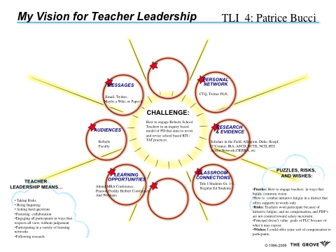

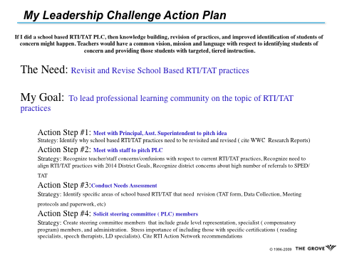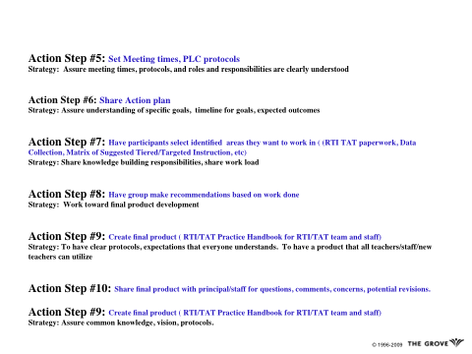

Teacher Leader Initiative: Massachusetts Cohort
Agenda for March 29, 2014

- What I Teach/Passion
  - Title I Reading Specialist Grades 1-3
  - Passion for Early literacy instruction

- Quick share in whole group: share focus of action plans or focus of potential action plans
  - Revisit and revise school based RTI/TAT practices
- Individual or small groups: subject-alike groups and/or geographic-alike groups or individual work: use the time to plan next steps, to research, to plan implementation of steps in your action plan -
  - Guiding questions:
    - What are your challenges?
      - Engaging teachers disgruntled about PLC work that goes no where
      - Engaging teachers disgruntled because PDP’s do not count toward salary increment
      - Initiative fatigue
    - What are your thoughts about working around/dealing with the challenge/s?
      - Look for early minority of those willing to engage
      - Encourage involvement as evidence of meeting professional culture standards in new teacher evaluation
    - Have you thought about or have you begun to map out a timeline for the capstone project?
      - Have mapped out matrix (see attached)
    - Along the same line, have you mapped the steps necessary to implement your action plan?
      - Have mapped out action plan steps (see attached)
    - What is the research that supports your action plan?
      - IRA, NCII, WWC, NBTS, ASCD, CIERA, NCLE, RTI Action Network, etc
    - What kinds of data are you using that support your plan?
      - School based screening/progress monitoring data,
      - Data on numbers of students referred to TAT/SPED
- Share out challenges and needed supports from the morning session; brainstorm possible solutions, supports, resources

Sample Letter to Stakeholders

April 2014
To: Mr. Johnson, Principal Roberts School
Ms. Diane Caldwell, Asst. Superintendent

From: Patrice Bucci

Re: CTQ/NEA Teacher Leadership Initiative 2014

A joint endeavor of the National Education Association, the Center for Teaching Quality, and the National Board for Professional Teaching Standards has embarked on an effort to develop a nationwide cadre of teacher leaders. The 2014 Teacher Leadership Initiative application process selected close to 200 teachers from across the country to take part in a yearlong effort to further develop teacher leadership skills that will enhance the profession. The goal is to create a coherent movement with accomplished teachers’ voices and expertise at its core.
As a participant in the inaugural cohort of the 2014 Teacher Leadership Initiative, I have the opportunity to engage in leadership work at the Roberts school that will be supported by the National Education Association, the Center for Teaching Quality, and the National Board for Professional Teaching Standards. Leadership training will be grounded in a competency framework using a blended delivery model that will focus on developing teacher leadership skills.
Participation requires a Capstone Project and leading a PLC for the Roberts School. At Mr. Johnson’s suggestion, the focus of the professional learning community will be on RTI and Tiered Instruction at the Roberts School.
Responses to Intervention initiatives are gaining ground in an effort to identify students at risk for difficulties in literacy acquisition. School districts are moving toward providing systems of tiered instruction and tiered intervention in an effort to identify those in need of early intervention, and reexamine the referral process to special education programs. The Individuals with Disabilities Act of 2004 (IDEA, 2004) focused on providing more effective instruction by encouraging earlier intervention (through the use of the RTI model). Many educators see the RTI model as a means to close the achievement gap, enabling teacher assistance teams to engage in early identification of students who have the potential of developing reading difficulties. RTI has the endorsement of numerous researchers and professional organizations (Fletcher et al; Fuchs et al., 2003).
Many schools are working to implement a range of educational initiatives. Teachers are overwhelmed with learning how to implement the Common Core Standards, understand new teacher evaluation processes, follow new core reading programs, and understand the importance of social emotional learning goals. It’s easy to see how teachers can become overwhelmed and possibly suffer from initiative fatigue.
In the age of high stakes accountability, more often than not, teachers and schools are judged by their at risk populations. More than ever, supporting teachers in their efforts to close achievement gaps should be of paramount importance. With shrinking budgets for professional development opportunities (Darling-Hammond, 2013) opportunities for teachers to engage in professional learning communities are scarce. And, with principals being hard pressed for time to be instructional leaders (EDWEEK, March 2014), the need for teacher leaders to facilitate professional learning communities grows.
Our district has designated a move toward implementing an RTI model as one of their goals. Principals are being asked to engage in careful TAT team processes. Higher expectations as a result of implementation of the Common Core Standards are likely to result in greater variability in student performance and increase need for differentiated approaches characterized by RTI (Wixson & Lipson, 2012). The need for teacher driven knowledge building of how teacher assistance teams implement an effective RTI model couldn’t be greater.
Revisiting and revising a school based RTI plan demands knowledge building, reviewing tiered instruction, examining best practices in formative assessment, reviewing data collection processes, and frameworks for providing teachers with actionable suggestions for working with their at risk students.
The opportunity to lead a school based professional learning community that centers on supporting teacher assistance teams, builds knowledge of the Response to Intervention model, and aligns with district goals is enhanced by your support and further enhanced by the support of the National Education Association and the Center for Teaching Quality.
As I go forward with this endeavor, I hope to encourage the members of the professional learning community to apply for NEA grant support. The application process requires evidence of sustainability; local union affiliates willingness to support the activities, and district support. I look forward to your support as I move forward as a Massachusetts representative of the 2014 Teacher Leadership Initiative.
Sincerely,

Patrice Bucci
Title Reading Specialist
Roberts School
2014 NEA/CTQ Teacher Leadership Participant

Sample Letter To Faculty

To: Roberts Faculty

From: Patrice Bucci,

Re: CTQ/NEA Teacher Leadership Initiative 2014

Dear Colleagues,
As a participant in the 2014 Center for Teaching Quality and NEA Teacher Leadership Initiative, my required Capstone Project will be to lead a PLC for the Roberts School. After initial discussion with Mr. Johnson, the suggestion was to focus on RTI and Tiered Instruction at the Roberts School.
After completing a needs assessment, we will go forward seeking participants for the PLC. We would hope that we could have input from across the grades as well as from specialists in compensatory programs. From then, we will craft an action plan, complete with goals. Roles and responsibilities of team members will be clearly outlined.
Participating in this PLC will serve as evidence for the professional culture standard for your teacher evaluation. Participants will be expected to engage in reading professional articles, researching tiered instruction, and formulating school wide suggestions for changes in practice that will further support teachers and students. Suggested readings will be provided for you.
It is anticipated that this process will involve approximately four meetings and possible some online work. Resources will be provided. Every effort will be made to pursue professional development points for work done.
Please consider participating in the PLC. It is the intent of the Center for Teacher Quality and the NEA to support teachers, develop teacher leadership and encourage teacher voice in the areas of policy and practice.
Let me know if you have any questions, comments or concerns about participating.

Thank you

Patrice Bucci, Title I Reading Specialist

_______I would like to participate in the Roberts CTQ/NEA PLC: RTI at the Roberts School

Name:_______________________ Grade/ Department________________________________________

Letter To Staff Regarding Needs Assessment
Dear Colleagues
As stated by Mr. Johnson at our last staff meeting, part of my responsibilities as a participant in the NEA/CTQ Teacher Leadership Initiative, I will be facilitating a school based PLC. And as Mr. Johnson indicated, he would like it to center on the TAT Team/RTI practices at the Roberts School. The goal is for a steering committee to revisit and revise TAT/RTI practices for the school year 2014-2015.
In order to begin this process, I am asking that you respond the following survey. Results will serve as a starting point for the PLC Steering Committee.
A letter will follow asking for participants. More specifics (goals, dates, expectations, pdp info, etc) will follow as well.
The NEA/CTQ Teacher leadership is in its inaugural year. The hope is to bring teacher voices to policy and practices.
Please respond to this survey by Friday, March 2014
Thank you in advance for taking the time to support this effort.
Patrice

Needs Assessment Survey: DRAFT Patrice Bucci
CTQ/NEA March 2014
Reflect on your knowledge level on the following topics:
- I have a clear understanding of major instructional shifts teachers need to take in order to fully implement the Common Core Standards
Adequate Needs Attention
- I have a clear understanding of the new PARCC assessments, how to best prepare students for them, and what that means for instruction across the grades.
Adequate Needs Attention
- I have a clear understanding of the formative assessments that are the most useful in predicting literacy acquisition.
- Adequate Needs Attention
- I have a clear understanding of school based RTI, tiered instruction, and progress monitoring practices.
Adequate Needs Attention
- There are clear and uniform data collection processes that are consistent from grade to grade that serves to drive instruction, identify needs, and document progress.
Adequate Needs Attention
- The TAT team offers actionable recommendations to support efforts to provide Tier 1 intervention.
Adequate Needs Attention
- The current TAT process /TAT form is helpful in documenting specific concerns for students.
Adequate Needs Attention
- I understand how to provide and document a range of targeted instruction for students of concern within Tier 1 (instructional practices used, materials used, duration, time, and frequency)
Adequate Needs Attention
- I understand the concepts of targeted instruction and targeted intervention.
Adequate Needs Attention
- I have adequate access to the expertise of compensatory program specialists (Ell, Behavior, OT, Speech, LD, Title I, Etc.).

Adequate Needs Attention

Professional Resources

National Board of Professional Teaching Standards
Center for Teaching Quality
National Education Association
International Reading Association
National Center on Response to Intervention
RTI Action Network
The Text Project
What Works Clearing House
Association for Supervision and Curriculum Development
Educational Leadership
EdWeek
National Center on Intensive Intervention
Reading Rockets
Center on Instruction
CIERRA
Professional Reading
Handbook of Reading Interventions, O’Connor
Reading Instruction that Works, Farstrup
Checking For Understanding, Fisher & Frey
Preventing Misguided Reading, Burkins
Understanding and Using Reading Assessment, Afflerbach
What Really Matters in Response to Intervention, Allington
Reading Instruction that Works, Pressley
Best Practices in Literacy Instruction, Gambrell, Pressley
Comments by PLC Participants

“My experience with working alongside a teacher leader has been nothing but positive and stimulating. A teacher leader must consider the school culture when trying to make change to support teacher learning and student learning. Patrice Bucci continuously fosters professional learning for all teachers. She is able to listen to colleagues and offer professional readings to expand their knowledge. As teacher leader, Patrice offers current research to teachers and facilitates professional learning among colleagues. Using summative data, Patrice collaborated with colleagues to analyze data to influence educational practice and student learning to foster school improvement. Patrice organized a collaborative group of teachers to consider the latest research, best practices and protocol to implement a response to intervention team. Teacher leadership is ways for teachers to use their voices to problem solve and gain the confidence to reclaim the teaching profession. Patrice Bucci is an excellent teacher leader model. She builds teacher knowledge, models best practices, and facilitates a collaborative environment for all teachers. Teacher leaders are a way to get our schools ready for 21st century learning.”
Ann Smith
Title I Literacy Specialist
Roberts School
Medford, MA

“Recently I participated in and RTI/TAT professional learning community led by Patrice Bucci, and NEA/CTQ teacher leader. Ms. Bucci’s excellent facilitation skills allowed for an environment of mutual respect amongst colleagues. Teachers worked collaboratively to analyze data, identify needs, and make decision that will improve teaching and learning in our school. Ms. Bucci’s sound knowledge of the subject matter provided participants with guiding questions to stimulate discussion, clarification when needed and constructive feedback. Participating in the PLC has been a most worthwhile experience. Ms. Bucci’s guidance has provided participants with the necessary knowledge and confidence to effectively promote needed change for school improvement.”

Jessie Reinold
English Language Learner Teacher
Roberts School
Medford, MA

Medford Public Schools
Lt. Milton F. Roberts Elementary School
35 Court Street
Medford, Massachusetts 02155

Kirk D. Johnson
Principal
October 17, 2014
The experience of working with the NEA/CTQ has been rewarding in many ways. It has provided the opportunity for teacher leadership, as well as promoting an effective avenue for collaborative teaching practices. Ms. Bucci has worked effectively with the principal and staff in designing sessions for teacher learning and development. Through the teacher leadership model, the Professional Learning Community (PLC) was formulated to advance the skills of our teachers and reflect on best practices for student growth and learning. I met with Ms. Bucci to discuss areas the PLC should focus on to improve student learning. The connection that is necessary for a principal and teacher leaders to work together was immediately in place, due to Ms. Bucci’s leadership style and working with her in the building for ten plus years. Although this is Ms. Bucci’s “official connections with a teacher leadership association, it is not her fist time in the role as a “teacher leader.”

The PLC is working to complete best practices in Tier I level of instruction within the RTI model. This high impact of research and analysis has promoted reflection and support in the growth of our teachers. It has also allowed the staff to use technology to design instruction as well as search out resource to improve student learning.

The paradigm of teacher leadership by the NEA/CTQ is an experience that all educational professionals that have an interested in leadership and may not want to be a school leader, should experience in their career. It is an opportunity to work collaboratively and effectively with colleagues and with their principal. It also allows principals the time to be part of a learning community, through the coordination of a teacher. School districts should explore additional opportunities for teachers to become teacher leaders for the improvement instruction and student learning.

Thank you for the opportunity to have the experience of the NEA/CTQ to be a part of our school community!

Kirk Johnson
Principal
Roberts School
Medford, MA

Going Forward

It is my hope that the work of the Roberts MTSS/RTI Professional Learning Community continues its efforts to engage in professional learning that is inclusive, engaging and meaningful. I hope that this year’s work will serve as a springboard for continued growth, serve as a model for teacher collaboration, and inspire others to find their voice and take on leadership ventures. The final meeting of the PLC included attention to grant opportunities offered by the NEA. Creating awareness of the rich resources the NEA offers will hopefully encourage deeper engagement with this organization. In order to sustain our efforts to support teachers as they aim to offer targeted instruction and targeted intervention to students, seeking funding for materials and professional development will be of critical importance. Examining the NEA grant opportunities will help to extend the impact of our efforts.
Professional development is a passion of mine, and I hope to continue to engage colleagues in ongoing reflection, mentor novice and veteran teachers, and encourage teachers to participate in the Center for Teaching Quality. The Center for Teaching Quality along with the NEA, offers access to many thought leaders in our filed, enables teacher to engage with others across the country, and provides access to a wide range of resources. This has been an enriching experience and I am so grateful to have been apart of it.

